Name: NGO TUNG CHUONG
ID: s225586848
GitHub: https://github.com/NoXxChapter/SIT221-DataStructure.git

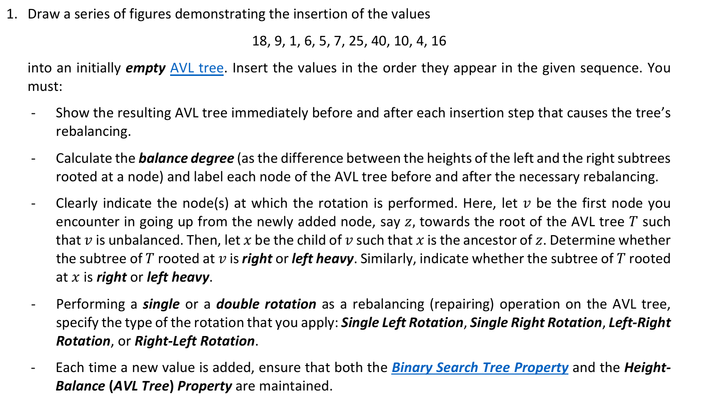
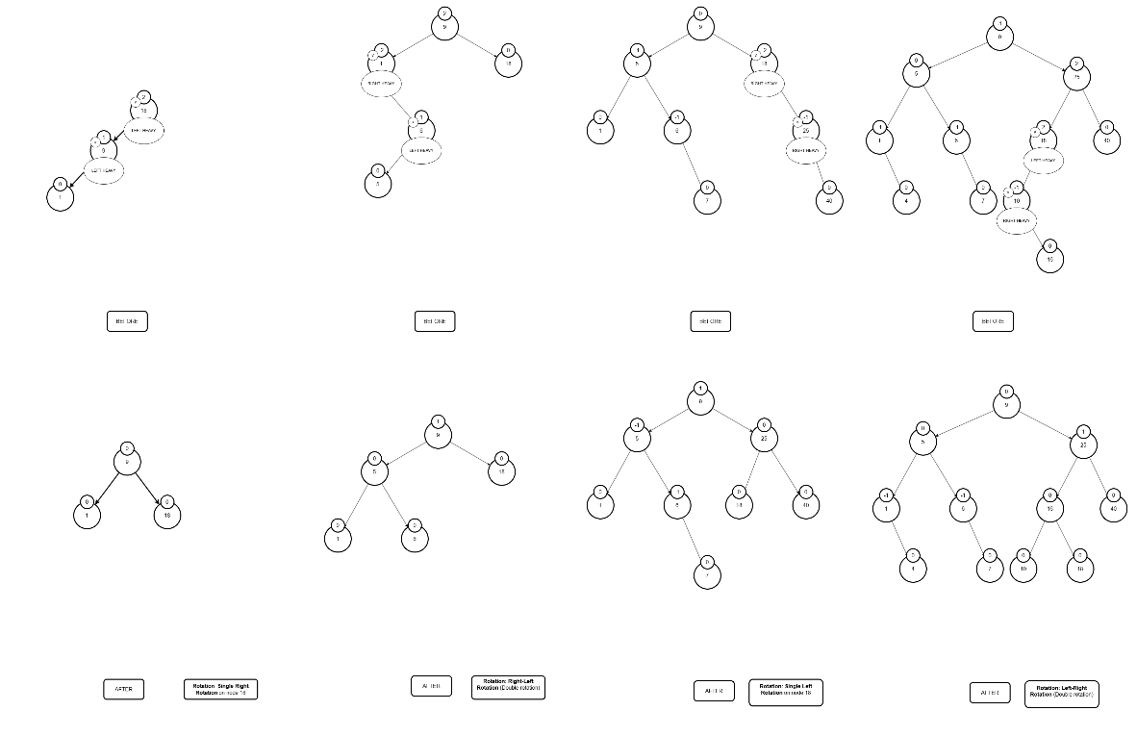
(please download the pic from GitHub, it better to view)

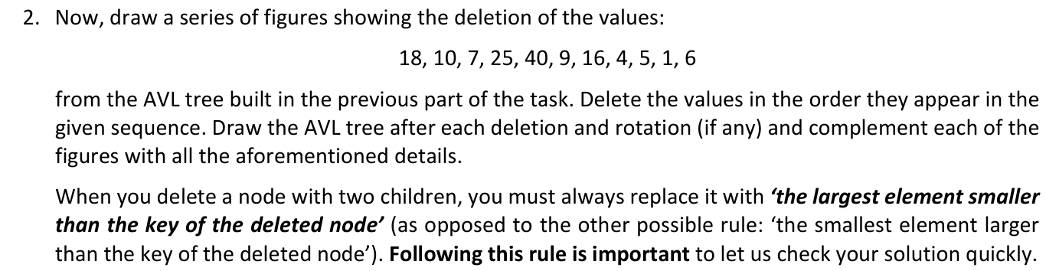
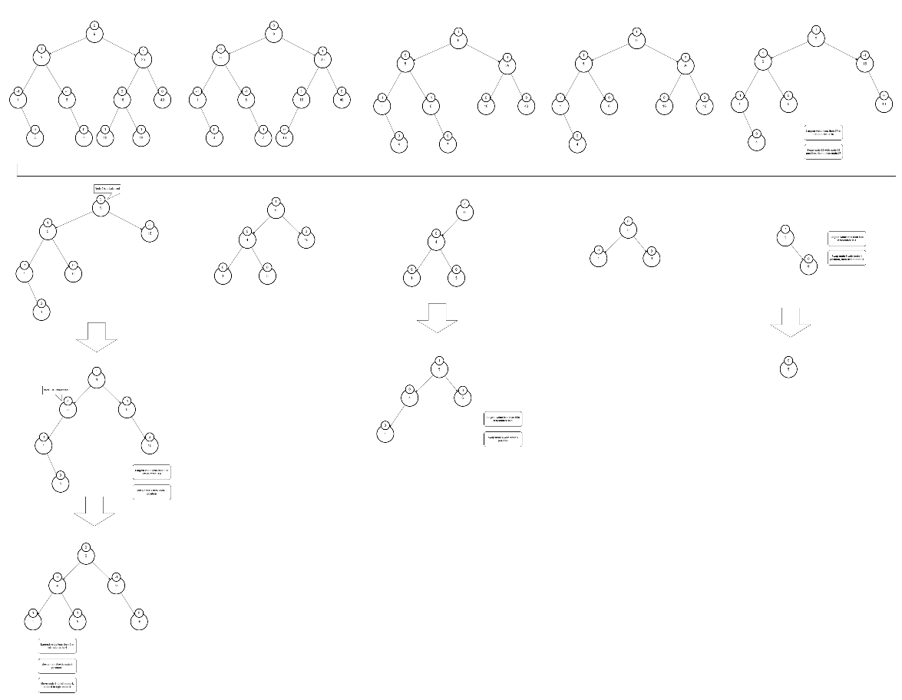
(please download the pic from GitHub, it better to view)

Task 3
getInorder(node, list) {
If node is null
return;
getInorder(node.left, list);
list.add(node.data);
getInorder(node.right, list);
}

balancedBST(list, start, end) {
if start > end
return null;
mid = (start + end) / 2;
newNode = new Node(list[mid]);

newNode.left = balancedBST(list, start, mid – 1);
newNode.right = balancedBST(list, mid + 1, end);
return newNode;
}
Performce an inorder traverse to extract all elements from the unsorted BST into a sorted array or list. By the time, to ensure the new tree is balanced $Olog\left(n\right)$ height, we find the middle element of the sorted list. Then later, we utilize the recursive to repeat for each other half of the list to create left and right subtrees.
The time complexity:
When we extracted all elements from unsorted BST. It only traverses each element once, so it takes $0(n)$ time. Also, with the “building” process, each insertion takes up only $O(1)$ each element. So, it also takes up to $O\left(n\right)$time. But by always picking the median as the root, the height of the resulting tree is guaranteed to be $Olog\left(n\right)$satisfying the balance requirement.

